**Mr. P.A.J. MIHIRAN.**

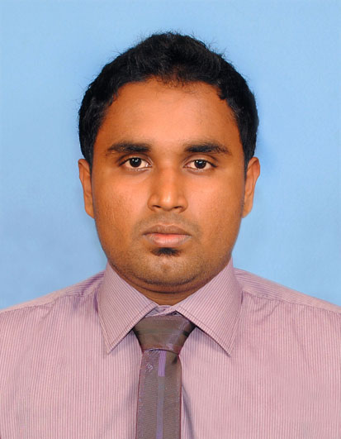

**No 17 Upali Mw,**

**Wadduwa, Sri Lanka.**

**Mobile : +94729599567**

**Email : jeevaka90@gmail.com**

**PERSONAL SUMMARY**

A results driven, self-motivated and resourceful Asst Electrical Engineer cum Quantity Surveyor working as part of a busy team effectively managing all the costs relating to building and civil engineering projects. Having a proven track record of minimizing the costs of a project and enhancing value for money, while still achieving the required standards and quality. Possessing excellent foresight & the ability to plan ahead when working on construction projects. Can communicate effectively with developers / contractors & would be an asset to any employer who respects loyalty & responsibility. Currently looking for an opportunity to join a dynamic, ambitious and growing company to forge a career as a first class quantity surveyor.

**KEY SKILLS AND COMPETENCIES**

* Taken-off quantities, prepared bid schedules and other bid documents
* Issued bid document packages to Subcontractor/ Vendors
* Valuated bids, negotiated and prepared subcontracts/ procurement documents
* Checked payment requests, and certified payment for subcontractors/ vendors
* Invoiced to Client, including monthly claims, variation claims and negotiation; measured final payment
* Pre-qualified sub-contractors/ vendors and processed subcontract/ procurement
* Produced budget and cash-flow forecasting
* Tracking actual costs compared with the budget, performed cost control

**Core Qualifications**

* Exceptional project management and cost allocation skills
* Excellent computer skills
* Willing to travel and work as many hours as necessary
* Dedicated to creating a comprehensive estimate that benefits the company and customer
* Reliable employee that has never missed a bid deadline

**ACEDAMIC QULIFICATION**

* **NATIONAL DIPLOMA IN ENGINEERING SICENCES (FOUR YEARS FULL TIME)**

(Institute of Engineering Technology Katunayake , Sri Lanka.)

* **CERTIFICATE IN QUANTITY SURVEYING**

(CADD Center Colombo , Sri Lanka.)

* **CERTIFICATE IN M.E.P QUANTITY SURVEYING**

(Advance Construction Technology Academy Colombo , Sri Lanka.)

* **DIPLOMA IN AUTO CAD**

(CADD Center Moratuwa, Sri Lanka)

* **DIPLOMA PROJECT MANAGEMENT**

(CADD Center Moratuwa, Sri Lanka)

* **CERTIFICATE IN COMPUTER APPLICATION**

(Apprenticeship Training Institute - Katubadde, Sri Lanka)

**STANDARD DOCUMENT FAMILIAR WITH**

* SMM7
* SLS 573

**COMPUTER LITERACY**

* Microsoft office Package (2003-2010)
* Auto Cad (2003 -2010)
* Internet & Email
* Ms-Project

**EMPLOYEMENT SUMMARY**

Jan2013 – April 2013 : Maxaire(P.V.T)Ltd.(Construction Project under the BOI)

Position : In Plant Trainee cum Quantity Surveyor

April 2013–to September 2012 : Ceylon Petroleum Corporation

Position : In Plant Trainee

Jan 2014 – April 2014 : Ceylon Electricity Board.

Position : In Plant Trainee

April 2014 – June 2014 : L.T.L Transformers (P.V.T) Ltd.

Position : In Plant Trainee

June 2014 – September 2014 : Roche Engineering (P.V.T) Ltd.

Position : In Plant Trainee

Sept 2014 – December 2014 : Venora Projects (P.V.T) Ltd.

Position : In plant Trainee cum Quantity Surveyor

Currently work in : Maxaire(P.V.T)Ltd.

Position : Estimation Engineer at Estimation & Designing Dept.

**PERSONAL INFORMATION**

Name : Perumpuli Arachchige Jeevaka Mihiran.

Date of Birth : 01.09.1990

Sex : Male

Religion : Buddhist

Civil Status : Single

Passport No : N 5606317

Permanent Address : No.17, Upali Mw, Wadduwa, Sri Lanka.

Contacts : +94729599567

Email Address : jeevaka90@gmail,com

**NON RELATED REFEREES**

**Mr. Fazal Ahmad Mr. G.C.S Feranando**

Manager – Technical & Operations Development Officer

Maxaire(pvt)Ltd. TRCSL,

Isipathana Rd, Alvitigala Rd,

Colombo-05 Narahenpita,

Mobile: 0712308761 Mobile: 0755589501

I do hereby solemnly and sincerely declare that the particulars furnished by me in this application are true and accurate to the best of my knowledge and belief.

01st December 2015 

Date Signature